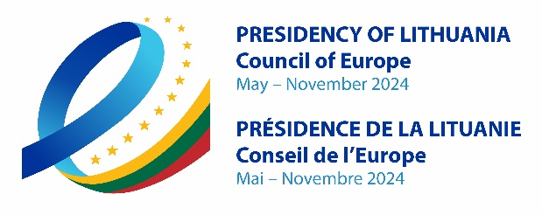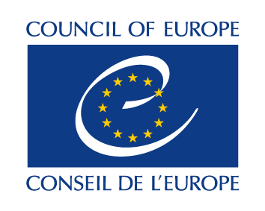

DECLARATION OF THE MINISTERS OF JUSTICE
OF THE MEMBER STATES OF THE COUNCIL OF EUROPE

On the occasion of the Conference “Towards Accountability for International Crimes Committed in Ukraine”
5 September 2024
Vilnius, Lithuania

We, the Ministers of Justice of the member States of the Council of Europe, convened in Vilnius, Lithuania, under the auspices of the Lithuanian Presidency of the Committee of Ministers of the Council of Europe, to address critical issues in international criminal justice related to the accountability for core international crimes committed in and against Ukraine;

Recalling the fundamental principles enshrined in the Statute of the Council of Europe, particularly the protection of human rights, the rule of law, and the pursuit of peace through justice and international cooperation;

Recalling Article 2(4) of the Charter of the United Nations, which states that all Members shall refrain from the threat or use of force against the territorial integrity or political independence of any State, or in any other manner inconsistent with the Purposes of the United Nations;

Recalling United Nations’ General Assembly Resolution ES-11/6 (2023) on Principles of the Charter of the United Nations underlying a comprehensive, just and lasting peace in Ukraine;

Recalling Council of Europe Parliamentary Assembly Resolution 2436 (2022) on “The Russian Federation’s aggression against Ukraine: ensuring accountability for serious violations of international humanitarian law and other international crimes”, and Council of Europe Parliamentary Assembly Resolution 2482 (2023) on “Legal and human rights aspects of the Russian Federation’s aggression against Ukraine”;

Reasserting our steadfast commitment to justice and international law, including international human rights law and international humanitarian law, as outlined in the Reykjavik Declaration adopted at the 4th Summit of Heads of State and Government of the Council of Europe;

Recalling the arrest warrants issued by the International Criminal Court in the context of the situation in Ukraine for Mr Vladimir Vladimirovich Putin, Ms Maria Alekseyevna Lvova-Belova, Mr Sergei Ivanovich Kobylash and Mr Viktor Nikolayevich Sokolov for their alleged responsibility for war crimes and crimes against humanity under the Rome Statute committed in Ukraine;

Referring to the decisions of the Council of Europe Ministers' Deputies adopted at their 1497th meeting on 30 April 2024 to authorise the Secretary General to prepare any necessary documents to contribute to consultations within the Core Group on a possible draft Agreement between the Council of Europe and the Government of Ukraine on the Establishment of a Special Tribunal for the Crime of Aggression of the Russian Federation against Ukraine, including its Statute, and on a possible draft Enlarged Partial Agreement governing the modalities of support to such a Tribunal, its financing and other administrative matters;

Recalling the establishment of the Register of Damage Caused by the Aggression of the Russian Federation against Ukraine by the 4th Council of Europe Summit of Heads of State and Government in Reykjavik on 17 May 2023, as well as the Declaration of the Informal Conference of the Council of Europe’s Ministers of Justice on 11 September 2023, in Riga, Latvia, on the occasion of the Conference “On the Path to Justice for Ukraine: Advancing Accountability, Reuniting Children with Their Families, and Supporting the Resilience of its Justice System”;

Reaffirming our unwavering dedication to the rule of law, particularly in the face of the blatant and widespread commission of international crimes against and in Ukraine;

Recognising the importance of ensuring accountability for international crimes, including the crime of aggression;

We declare the following:

1. We reaffirm the undisputable necessity of establishing an effective Special Tribunal for the Crime of Aggression against Ukraine, capable of delivering true and timely justice by holding those most responsible accountable. It should meet the expectations of Ukraine and of the international community as a whole, apply international law and enjoy broad cross-regional support to guarantee its legitimacy.

2. We welcome the efforts of the Council of Europe to advance the establishment of a Special Tribunal for the Crime of Aggression against Ukraine, facilitated through the preparation and presentation of a bilateral Agreement between the Council of Europe and the Government of Ukraine concerning the Establishment of a Special Tribunal, its Statute and a draft Enlarged Partial Agreement outlining the modalities of cross-regional support for such a Tribunal. We encourage member States to cooperate with such a Special Tribunal, including through the conclusion of cooperation agreements as necessary and appropriate.

3. We reaffirm the critical importance of ensuring that the future proceedings of a Special Tribunal adhere to stringent requirements. These proceedings should be based on the principles and rights enshrined in the European Convention on Human Rights and the case law of the European Court of Human Rights, particularly emphasising the right to a fair trial by an independent and impartial court, access to a lawyer, the timely examination of cases, and the enforcement of final and binding judicial decisions without undue delay.

4. While emphasising the importance of fair trial guarantees and in-person trials, we acknowledge the necessity of proceedings in absentia in the interest of justice and encourage the harmonisation of legal standards to ensure fairness and justice in respective national proceedings. We also call for further ratifications of the Second Additional Protocol to the European Convention on Mutual Assistance in Criminal Matters, as well as the European Convention on Extradition and its Protocols.

4Bis. We welcome the work of the Council of Europe in expert bodies such as the European Committee on Crime Problems and propose an assessment at intergovernmental level of the functioning of the Council of Europe's criminal law conventions concerning proceedings in absentia, with the objective of considering potential revisions and thereby address the evolving challenges more effectively.

5. We acknowledge the challenges of collecting, sharing and verifying evidence in cases of international crimes and commit to developing innovative, effective, and secure mechanisms for the collection, verification and sharing of evidence among jurisdictions.

6. We emphasise the need for enhanced cooperation among member States, international organisations, and civil society to effectively collect and share evidence, in order to prosecute perpetrators of international crimes committed in Ukraine and enforce judgments. We also request that the European Committee on Crime Problems and the European Committee on Legal Co-operation take the lead in following up on these efforts to guarantee effective, sustained and well-coordinated action.

7. We call on member States and other nations to actively support and contribute to the financing and operational resources of a Special Tribunal through an Enlarged Partial Agreement. We commit to engaging with international partners to secure broad recognition and support for a Special Tribunal’s mandate and decisions.

We, the Ministers of Justice, resolve to work collectively to implement the principles and commitments outlined in this Declaration. We mandate the Council of Europe, in collaboration with its member States and the international community, to take all necessary steps to ensure accountability for international crimes committed in and against Ukraine, to contribute to the establishment of a Special Tribunal for the Crime of Aggression, and to reinforce the international legal order.

